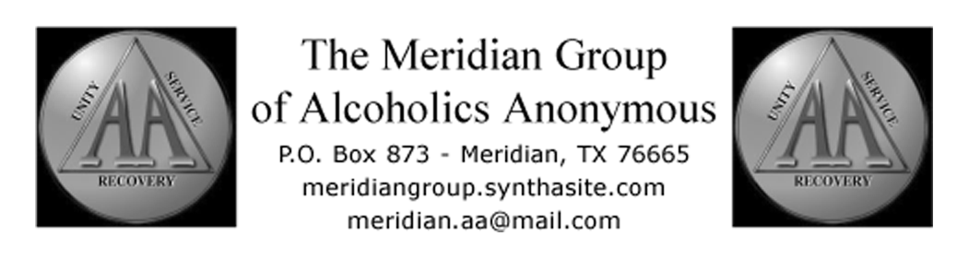
September 3, 2011 District 92 Meeting
Submitted by David A (substituting for Tammy A, Meridian Group GSR)

DCM Gorden P reported the district's bank balanced at $241.23.

Briefly reviewed finished Community Outreach Flyers.

Gorden announced he cannot attend NETA Assembly due to family obligation. David A is still listed as Alternate, and will be attending, so agreed to serve in that capacity.

David A was asked to check into switching district bank account from Community Bank to First Security State bank (FSSB, as FSSB has branches in Clifton, Meridian, Whitney, and Cranfills Gap. If free checking is offered at FSSB, Gorden was given approval to make the change.

Tammy was briefed on what to expect at the Fall Assembly and how AA is structured.

David was asked to draft District by-laws, based on other districts, for future review. He was asked to keep them concise, concentrating on how the district is set up to operate.

Mention was made of a new group being formed off FM 219 just outside Cranfills Gap. First meeting is tentatively planned for 6:30 p.m. Tuesday, Sept. 13.

Next District 92 meeting is tentatively scheduled for 1 p.m. Saturday, Oct. 1, 2011, at the Lake Whitney Group.

