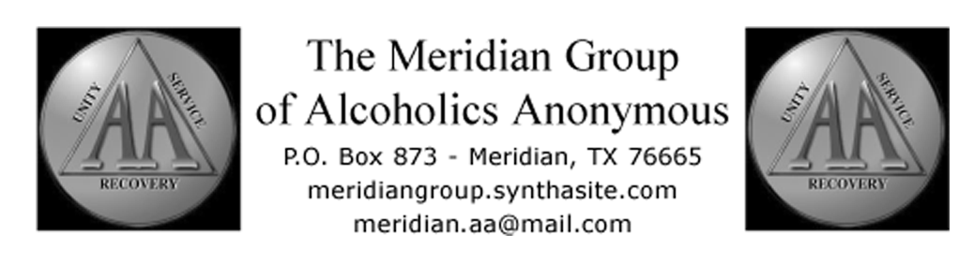
July 2011 Intergroup Representative’s Report:
Submitted by David A, Alternate Representative

Representation of the area groups continues to grow with approx. 18 people present at the Monday, June 20 2011, meeting.
Highlights of the meeting included discussion on possibly lowering prices of anniversary chips, currently priced at over $3 each. Changes to be looked at include possible discounts for multiple purchases. Currently enough profit margin exists to safely lower prices considerably.
Discussion was held on a planned family-oriented event sometime in September, to include a cookout, games, speakers/meeting, etc. Possible locations are being firmed up by a committee.
Considerable discussion was held on setting up as Facebook page for Intergroup, to promote area group events, post the monthly newsletter, etc. Many were not familiar with particulars of Facebook, and expressed concern for possible anonymity breaks. John O’H was put in charge of research, and I passed along the contact info for NETA Area Chair Tom M for more info. It was noted that the Triangle Group has a page with over 90 members.

